#include<stdio.h>

#include<stdlib.h>

#include<string.h>

//31337=0111101001101001

char char1[100];

int intoints[100]={0};int xorints[100];

int main()

{

int i=0;int j;

void grouper(char \*char1);

void inter2(char \*char1,int i);

gets(char1);

grouper(char1);

while(char1[i]!='\0')

{

inter2(char1,i);

i=i+2;

}

printf("encrypted message ist:");

for(j=0;intoints[j]!=0;j++)

{

xorints[j]=intoints[j]^31337;

printf("%d\t",xorints[j]);

}

return 0;

}

void grouper(char \*char1)

{

int i=0;

while(\*char1!='\0')

{

char1++;

i++;

}

if((i%2)==1)

\*char1=' ';

i=0;

}

void inter2(char \*char1,int i)

{

char ascii[17]={"0000000000000000"},cacheascii1[9]={"00000000"},cacheascii2[9]={"00000000"},ascii1[9]={"00000000"},ascii2[9]={"00000000"};

char \*asciipointer=ascii;char \*asciipointer1=ascii1;char \*asciipointer2=ascii2;char \*cacheasciipointer1=cacheascii1;char \*cacheasciipointer2=cacheascii2;

char \*endptr;

itoa(char1[i],cacheasciipointer1,2);

//while(\*asciipointer!='\0')

//asciipointer++;

itoa(char1[i+1],cacheasciipointer2,2);

asciipointer1=asciipointer1+(8-strlen(cacheascii1));

asciipointer2=asciipointer2+(8-strlen(cacheascii2));

strcpy(asciipointer1,cacheascii1);

strcpy(asciipointer2,cacheascii2);

strcpy(asciipointer,ascii1);

asciipointer=asciipointer+8;

strcpy(asciipointer,ascii2);

//printf("%s\t%s\t",ascii1,ascii2);

//printf("%s\t",ascii);

intoints[i/2]=strtol(ascii,&endptr,2);

}

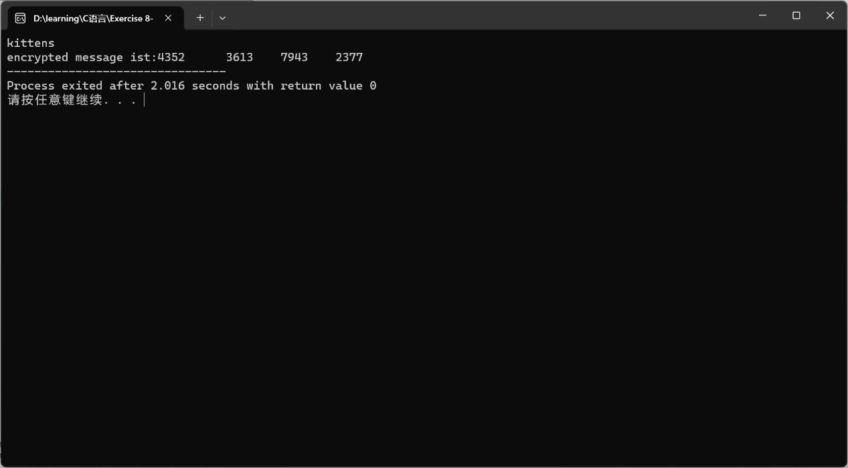

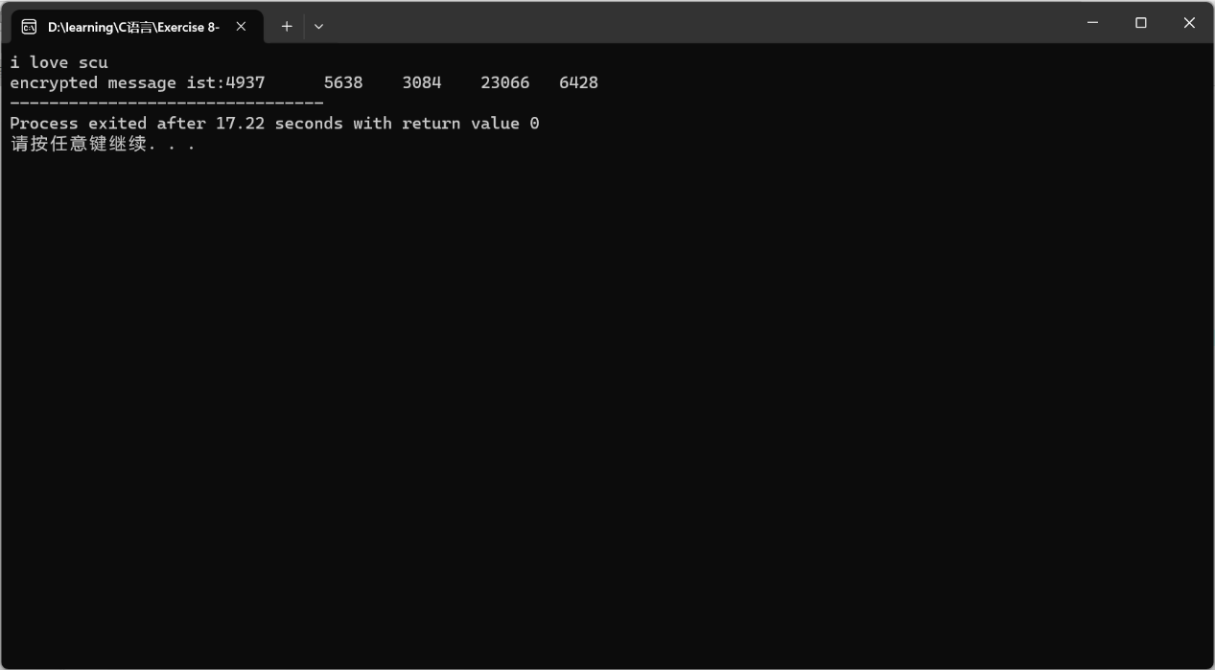

#include<stdio.h>

#include<stdlib.h>

#include<string.h>

//31337=0111101001101001

char char1[100];char dechar[100];

int intoints[100]={0};int deintoints[100]={0};int xorints[100];

int main()

{

int i=0;int j;int number;

void degrouper(int deintoint,int j);

void deinter2(int intoints,int i);

printf("enter the numbers of encrypted message bitte\n");

scanf("%d",&number);

for(j=0;j<number;j++)

{

scanf("%d",&xorints[j]);

intoints[j]=xorints[j]^31337;

//printf("%d\n",intoints[j]);

}

while(intoints[i]!=0)

{

deinter2(intoints[i],i);

i=i+1;

}

printf("decrypted message ist:");

for(j=0;j<number\*2;j++)

{

degrouper(deintoints[j],j);

}

return 0;

}

void degrouper(int deintoint,int j)

{

dechar[j]=deintoint;

printf("%c",dechar[j]);

}

void deinter2(int intoint,int i)

{

char ascii[17]={"0000000000000000"},cacheascii[17]={"0000000000000000"},cacheascii1[9]={"00000000"},cacheascii2[9]={"00000000"},ascii1[9]={"00000000"},ascii2[9]={"00000000"};

char \*asciipointer=ascii;char \*cacheasciipointer=cacheascii;char \*asciipointer1=ascii1;char \*asciipointer2=ascii2;char \*cacheasciipointer1=cacheascii1;char \*cacheasciipointer2=cacheascii2;

char \*endptr;

itoa(intoints[i],cacheasciipointer,2);

asciipointer=asciipointer+(16-strlen(cacheascii));

strcpy(asciipointer,cacheascii);

asciipointer=ascii;

strcpy(ascii1,asciipointer);

ascii1[8]='\0';

asciipointer=asciipointer+8;

strcpy(ascii2,asciipointer);

//printf("%s\t%s\t",ascii1,ascii2);

//printf("%s\t",ascii);

deintoints[2\*i]=strtol(ascii1,&endptr,2);

deintoints[2\*i+1]=strtol(ascii2,&endptr,2);

//printf("%d\t%d\t",deintoints[2\*i],deintoints[2\*i+1]);

}

